
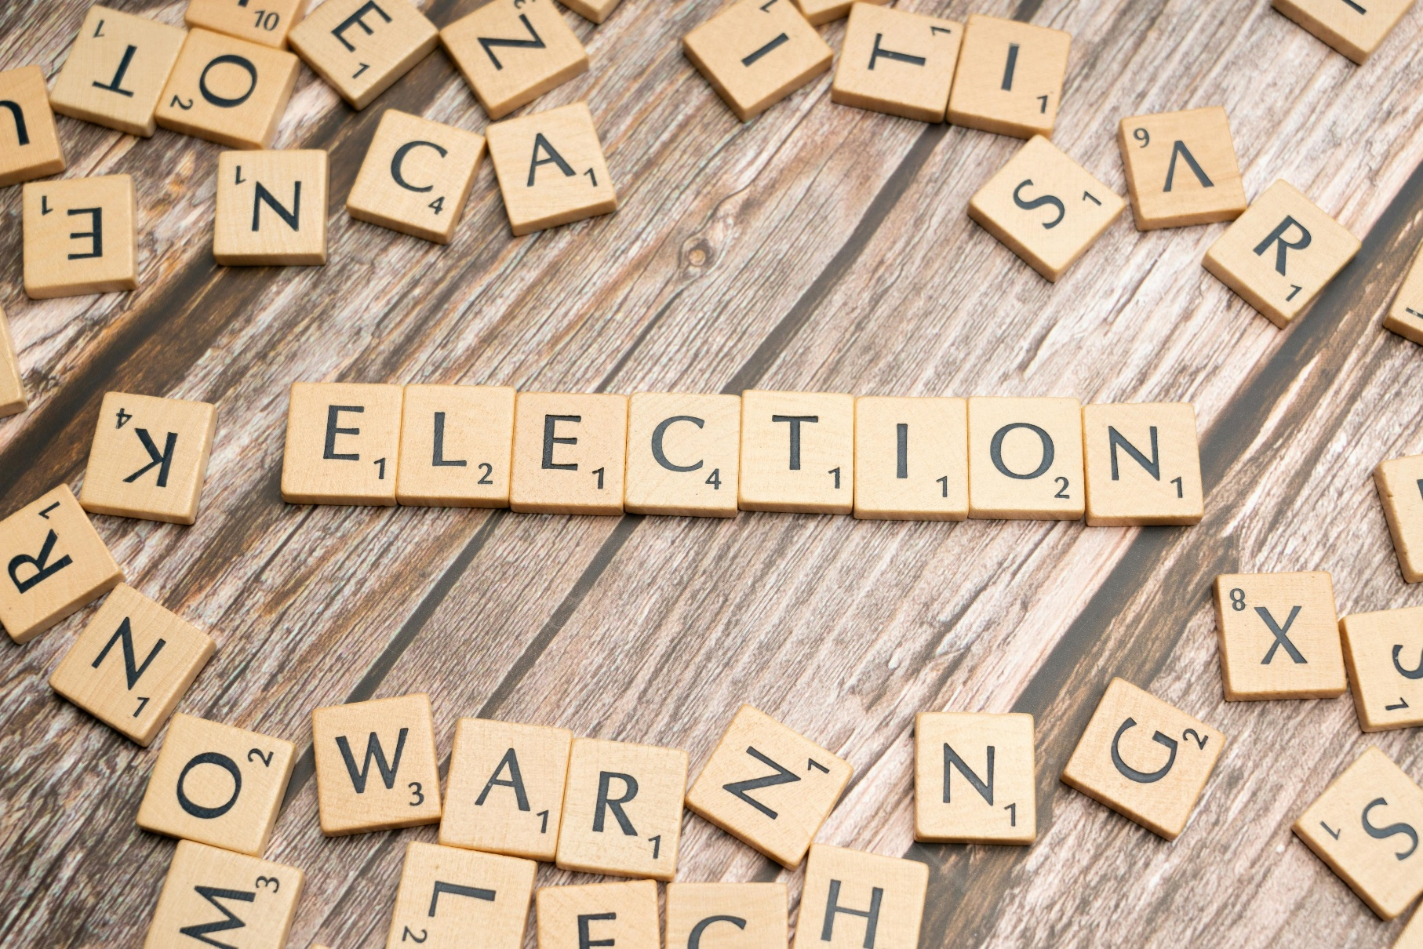
Online hate narratives during Dutch Municipal elections 2026

Written by
Adinde Schoorl
2026
Table of contents

International Network Against Cyber Hate – INACH 2
INtroduction 3
Chapter 1: Dutch municipal elections 4
chapter 2: Data 9
Conclusion 22
recommendations 22
Bibliography 23

International Network Against Cyber Hate – INACH
INACH was founded in 2002 to use intervention and other preventive strategies against cyber hate. The member organisations are united in a systematic fight against cyber hate, for example as complaints offices, monitoring offices or online help desks. In their respective countries, they provide important contacts for politicians, internet providers, educational institutions, and users.

Funding for INACH is provided by its members, the European Commission, the BPB and other donors. The International Network Against Cyber Hate (INACH) unites multiple organizations from the EU, Africa, Albania, Israel, North Macedonia, Russia, South America, and the United Kingdom. While starting as a network of online complaints offices, INACH today pursues a multi-dimensional approach of educational and preventive strategies.

This publication has been produced with the financial support of the Citizens, Equality, Rights and Values (CERV) Programme of the European Union. The contents of this publication are the sole responsibility of the International Network Against Cyber Hate and can in no way be taken to reflect the views of the European Commission.

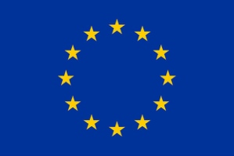
Supported by the Citizens, Equality, Rights and Values (CERV) Programme of the European Union

Introduction
Elections are increasingly taking place within a digital environment in which online hate speech shapes political discourse in complex and often subtle ways. A central challenge is the prevalence of so-called borderline content: messages that may not clearly meet the legal threshold of illegality, yet still contribute to harmful narratives, polarization, and the normalization of exclusionary rhetoric. In this context, political actors play a crucial role. While instruments such as the Council of Europe Recommendation on Combating Hate Speech (CM/Rec(2022)16) underline the importance of codes of conduct and the responsibility of politicians to engage in respectful, rights-based communication, the reality in online spaces often diverges from these standards. Hate speech is increasingly normalized, and persistent narratives—particularly those targeting marginalized groups—are strategically amplified and capitalized on within political campaigning. This dynamic raises important questions about accountability, the effectiveness of existing regulatory frameworks, and the broader impact of digital communication on democratic processes.
In 2025, we monitored the Dutch national elections, mapping the online hate narratives that emerged during the campaign period. In March 2026, we conducted a similar analysis during the Dutch municipal elections. The objective of this report is to identify and assess the online hate narratives circulating both among users and within political communication, including those spread or reinforced by local and national politicians. The report concludes with a comparison to the findings from the 2025 national elections and provides recommendations for future policy and practice.

Chapter 1: the Dutch municipality elections

  - Context

Every four years Dutch citizens elect their local representatives in the municipalities where they live. Voting is not an obligation, it is a right, and the turnout is generally lower than during national elections. National parties participate with their local departments but there are also many local parties that originate in certain municipalities and only participate there. The elections this year took place on 18 March 2026.

There is both a clear increase in online hatred during local elections and a growing awareness of the issue among political actors and institutions. During the 2022 municipal elections, for instance, there was a threefold increase in threats and violence directed at local politicians, highlighting how online hostility can translate into real-world risks (NOS 2022).
At the same time, social media has become an indispensable tool for local politicians, particularly during campaign periods, as it allows them to reach and engage voters in a political arena that traditionally struggles with lower visibility and turnout. However, this reliance on social media comes with significant downsides: research indicates that around half of local politicians with public social media accounts experience online hate, and that the more visible they are, the more likely they are to become targets. This creates a fundamental dilemma—while visibility is necessary to gain public support, it simultaneously exposes politicians to increased levels of abuse and intimidation (van Veluwen 2022).
One grave example of what local politicians must endure is the case of Anja Schrage in the town of Warmond. During the municipal elections of 2026, bullet holes with blood around it were drawn on campaign posters where her face appeared (de Teyding 2026). Anja Schrage is a transgender woman and these attacks are a clear example of anti-trans hate.
In response to these growing challenges, new initiatives have emerged. During the 2026 elections, eight political parties—including CDA, ChristenUnie, D66, GroenLinks, PvdA, Volt, and VVD—jointly signed and presented a protocol aimed at combating online hate. This protocol not only provides practical guidance for local governments and political parties on how to respond to online abuse and digital aggression but also introduces the concept of an “elf army”: a coordinated effort by colleagues and supporters to actively counter harmful narratives online. By publicly supporting targeted politicians, these networks aim to reinforce norms of respectful communication and ensure that those facing online hate do not feel isolated (ibestuur 2026).

  - Political parties

While politicians are often the targets of online hate, they can also play a role in amplifying or normalizing it. An analysis of Dutch media coverage during these municipal elections points to several examples, particularly among parties on the radical and extreme right of the political spectrum. The Forum voor Democratie (FvD) stood out in this regard, achieving significant electoral success with gains in more than 100 municipalities, including 57 where it had not previously fielded local candidates, and emerging as the largest party in two municipalities (Hart van Nederland 2026).
At the same time, the party’s campaign was marked by controversy surrounding several candidates on local electoral lists who had previously expressed racist and antisemitic views, maintained links to extremist networks, or engaged in rhetoric that appeared to justify or glorify acts of terrorism. In one widely reported case, a candidate stated that he understood the actions of Anders Breivik—responsible for killing more than 80 people in 2011 Norway attacks—and expressed support for the Christchurch mosque shootings. Despite public outrage, these candidates were not removed from party lists, suggesting that candidate selection processes may contribute to the normalization of more radical or exclusionary viewpoints (Jonet 2026). According to research FVD voters do not necessarily view these extreme candidates as a problem although they would prefer that the candidates would be taken of the party’s representatives lists. When the FVD refused to remove the controversial candidates from their lists, political parties in several municipalities indicated they would not cooperate with the FVD in their local government (Lubbe 2026).
The party’s campaign strategy further reinforced this dynamic through a highly centralized approach. The national leadership coordinated messaging across local branches, with all local programmes published on a central platform and campaign materials—such as posters and flyers—featuring the national leader, Lidewij de Vos, rather than local figures. On social media, local branches focused less on municipal issues and instead amplified national narratives, frequently sharing speeches by de Vos. For example, campaign messaging included videos addressing concerns about safety in areas surrounding large asylum reception centres, thereby framing local political debates through broader national themes related to migration and security (Arnoldy, van der Borst & van der Pol 2026).

The Partij voor de Vrijheid (PVV) did not run a centralized campaign during the municipal elections, largely reflecting the party’s highly centralized internal structure under its leader, Geert Wilders. As the PVV does not operate with a traditional membership base and decision-making remains concentrated at the top, the party lacks the broader organizational capacity typically required to coordinate a strategic, nationwide local campaign. Instead, campaign activity was limited and largely ad hoc. Wilders himself made appearances in selected municipalities, particularly in locations where plans for asylum reception centres had sparked local opposition, as part of his so-called “AZC tour,” where he voiced support for protests against these developments. Beyond these targeted visits, however, there was little evidence of a coordinated top-down campaign effort. Even on X—his primary and most frequently used communication channel—Wilders devoted relatively little attention to the local elections.
At the local level, however, there were reported instances in which PVV-affiliated actors employed divisive or hostile narratives online. In Steenbergen, a local PVV branch shared an AI-generated video on Facebook depicting a distressed couple being followed by a group of asylum seekers, accompanied by the caption: “No wonder you can’t get a house.” In another case, in Emmen, a PVV party member responded to a Facebook comment suggesting that residents near an asylum reception centre should purchase an air rifle by replying that it should be used “only [to shoot] pests.” These examples illustrate how, even in the absence of a centralized campaign strategy, local actors may still engage in or amplify harmful online narratives targeting specific groups (Arnoldy, van der Borst & van der Pol 2026).

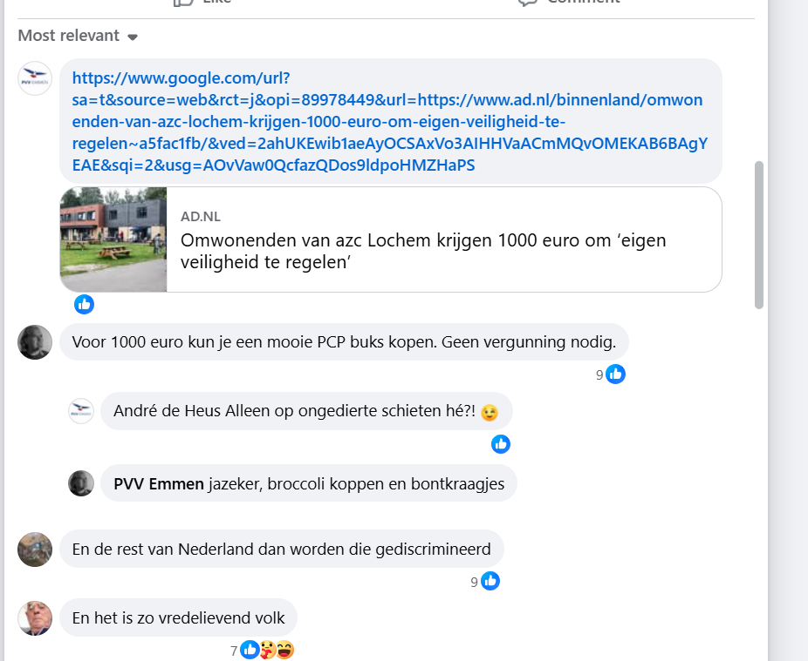

It was the first time that a PVV department participated in the local elections in Steenbergen. They won 4 seats during the elections in March 2026.
A huge part of their campaign with their account on Facebook was to be against the opening of an asylum-seeking centre in Steenbergen and to advocate against ‘Islamisation’ of society. The Facebook page of PVV Emmen shared what could be best summarized as mostly anti-asylum-seeking centres content.
Both accounts also shared many posts from the provincial PVV account ‘PVV Noord Brabant’ which primarily posts about ‘Islamisation’, remigration and the ‘threat’ from refugees entering the Netherlands.

Apart from the electoral gains of the Forum voor Democratie (FvD), the most notable outcome of these municipal elections was the strong performance of local parties. In numerous municipalities, newly established local movements secured the largest share of seats, despite not having existed just four years earlier. One of the most striking examples is Richard de Mos and his party Hart voor Den Haag, which achieved a major victory in The Hague by winning 16 out of 45 seats (BNR 2026). Many of these local parties were founded by politicians who had previously been affiliated with the Partij voor de Vrijheid (PVV) or FvD but became disillusioned with the strategies and centralized control of their national counterparts. In addition, a significant number of these initiatives emerged in response to local unrest and concerns over the establishment of asylum reception centres, once again highlighting the persistence and local resonance of xenophobic narratives within political mobilization at the municipal level (Arnoldy, van der Borst & van der Pol 2026).

In conclusion, much of the hate in this context that is observed is implicit, reflected in both the composition of candidate lists and the absence of clear norms or boundaries set by far-right parties, contributing to the normalization of exclusionary rhetoric. At the same time, there remains a clear and persistent trend of xenophobic narratives, particularly targeting asylum seekers and Muslims, which are actively leveraged by local politicians and, in many cases, yield electoral success.

Chapter 2: Data

2.1. EOOH dashboard

For this research, the European Observatory on Online Hate (EOOH) monitoring dashboard was used. The dashboard analyses data from multiple social media platforms through customised search channels. Each channel was configured with specific keywords and search terms related to key themes such as migration, identity, and politics, allowing for targeted retrieval of relevant posts and comments. This setup enabled systematic tracking of online discourse, while manual verification and annotation provided qualitative insights into tone, framing, and narrative patterns that automated tools alone could not fully capture. The AI built for the dashboard analyses and determined every scraped comment and determines its level of toxicity.

Here is an overview of the four created channels for this part of the research:

- Anti-LGBT+ channel: From experience in monitoring we know that much of the online hate focuses on the ’culture war’ by targeting the LGBT+ community. Keywords were used that are commonly associated with anti-LGBT+ hatred.
- Anti-immigration channel: From experience in monitoring we also know that much of the online hate focuses on intersectional hatred that could be defined as anti-immigration but includes anti-immigration hate, anti-muslim hate, xenophobia and racism. Keywords were used that are commonly associated with anti-immigration hatred, anti-muslim hatred and racism.
- Neutral words channel: with keywords related to elections such as ’municipality’ ’municipality elections’ and ’municipality elections 2026’.
- Woke channel: During local elections often there are local topics that are associated with ’wokism’ such as windmills, green energy, etc.. Therefore we also created this channel with keywords such as ’woke’ ’nitrogen madness’ and ’wind turbines’.

2.2. Channels

Anti-LGBT+ channel

Date | 1 March - 24 March 2026
Amount | 31,895 posts
% that was toxic of the total dataset | 22.4 % (7,139)
Average toxicity score | 0.29 (0-1)
Platforms where the data was mostly found | Twitter (80%), Facebook (11%) and Youtube (4%)
Messages with high toxicity are more frequent on | Twitter (80.4%)
Often involved | Sexism (64%)
% of the posts have a toxicity score of 0.8 or higher (on a scale of 0-1) | 1.2% of the posts

The dataset analyzed covers the period from March 1 to March 24, 2026, and consists of 31,895 Dutch-language posts, all written in Dutch. Of these, 7,139 posts—representing 22.4% of the dataset—were identified as toxic, with an average toxicity score of 0.29. A smaller subset, 1.2% of posts, exhibited particularly high toxicity levels, scoring 0.8 or higher. Most of the data was collected from Twitter, which accounted for 80% of posts, followed by Facebook (11%) and YouTube (4%). Notably, highly toxic messages were disproportionately concentrated on Twitter, comprising 84.4% of such content. In terms of thematic patterns, sexism emerged as the most prevalent form of toxicity, present in 64% of toxic posts, while approximately 11% of these messages contained violent language. Frequently occurring keywords in toxic messages included “aanvallen” (attacks), “Kaag” (referring to former party leader of the D66 political party), “Arabië,” “hypocriet” (hypocrite), and “dood” (death), indicating a mix of political targeting, identity-based hostility, and aggressive rhetoric.

The word cloud below shows the words most used in this channel. There are very few words logically associated with the content in this channel, like ‘flikker’ (faggot) or ‘nicht’ (sissy) and ‘pisnicht’ (faggot). It shows the international issues like in the other channels (Israel, Ukraine). The fact that the word Kaag (the last name of the former leader of the dutch D66 party) appears so often is very interesting. Most of the content that mentions her, connects it to Rob Jetten, who is now the party leader and the prime minister of the Netherlands. He receives a lot of anti-LGBT+ hate being the first out gay prime minister in the Netherlands. Finally, there are two things that stand out in this wordcloud since they are not necessarily connected to anti-LGBT+ hate:

- There are a lot of references to antisemitism (antisemitisme (antisemitism), Joden (Jews), jodenhaat (antisemitism). Most of these content refers to the Dutch prime minister Jetten not doing enough to protect the jews or only referring to antisemitism by the political party the FVD and not pointing towards the antisemitism that comes from Muslims.
- There are a lot of references to left wing politics with words such as GroenLinks (Green Party), links and Linkse (left). The content containing those words mostly link the Green Party to the party D66 and their progressive politics.

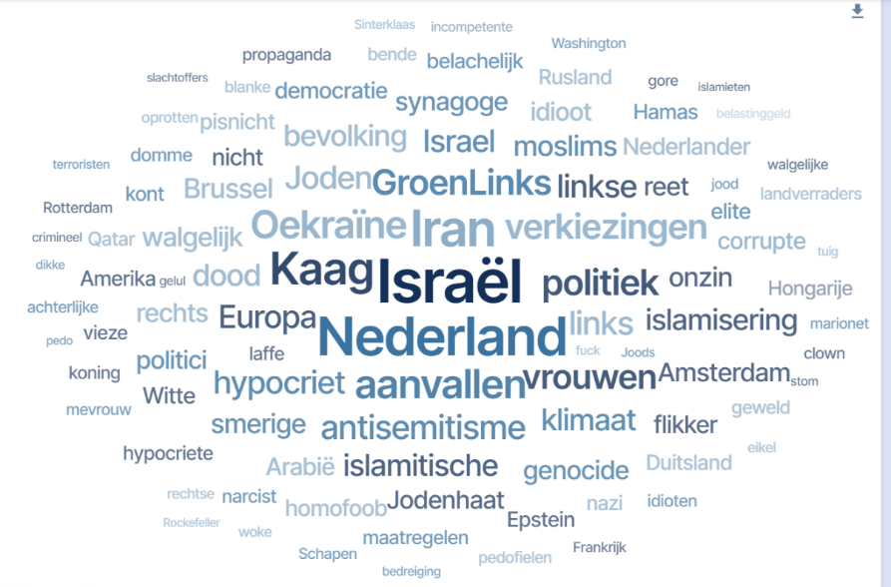

Anti-immigration hate channel

Date | 1 March 2026 - 24 March 2026
Amount | 55,430 posts
% that was toxic of the total dataset | 12,338 (22.3 %)
Average toxicity score | 0.30 (0-1)
Platforms where the data was mostly found | Twitter (74%), Facebook (12%) and Youtube (6%).
Messages with high toxicity are more frequent on | Twitter (76.3%)
Often involved | Racism (68%)
% of the posts have a toxicity score of 0.8 or higher (on a scale of 0-1) | 1.1 %
% of the toxic messages contained violent language | 18 %

The dataset analyzed covers the period from March 1 to March 24, 2026, and consists of 55,430 posts, all of which are written in Dutch. Of these, 12,338 posts—representing 22.3% of the dataset—were identified as toxic, with an average toxicity score of 0.30. A smaller proportion, 1.1% of posts, reached very high toxicity levels, scoring 0.8 or higher. Most of the data was collected from Twitter (74%), followed by Facebook (12%) and YouTube (6%). Highly toxic messages were predominantly found on Twitter, accounting for 76.3% of such content. In terms of thematic patterns, racism emerged as 18% of these messages included violent language. Frequently occurring keywords in toxic messages included “Israël,” “homo” (gay), “islamitische” (islamic), “Nederland” (the Netherlands), and “Europa” (Europe), pointing to discussions centered around identity, religion, and geopolitics.

The content is this channel heavily focuses on the conspiracy theory of Islamisation, is anti-immigration and calls for the closure of asylum-seeking centres and deportation of Muslims. There is also quite some content mentioning the conspiracy theory of the Great Replacement. However, the same occurred during the national elections of 2025 and in this context it is not necessarily linked to any local issues.

In the world cloud one can see the same pattern as in the other channel; most of the words are associated with international issues, like Israel and Europe. There are some links to politics, like ‘’GroenLinks’’ (Green Party) and ‘’verkiezingen’’ (elections). There are some links to local issues with the mentioning of cities and towns in the Netherlands: Amsterdam, Hardenberg, Nijmegen, Amersfoort. Going through the content with the word Amsterdam in it in this channel, it mostly refers to the supposed Islamisation of the city, its mayor who apparently permits it and many references to how the city has been taken over by Muslims. The content with Hardenberg exclusively focuses on problems with the asylum-seeking center there and calls for closing the borders of the Netherlands. The content with Nijmegen focuses mostly on referring to it as a leftwing city that should therefore have an asylum-seeking center. It is interesting to note that some of the content in the channel linked to Amersfoort is created by the local FVD party and solely focuses on preventing the opening of an asylum-seeking center there.

There are references to xenophobia such as ‘’islamitische’’ (islamic), ‘’jodenhaat’’ (antisemitism), ‘’vluchtelingen’’ (refugees) and ‘’hoofddoek’’ (headscarf). The content in the channel containing references to Jews often link it to Muslims supposedly hating them or referring to the strange discussion which group is hated more in the Netherlands.

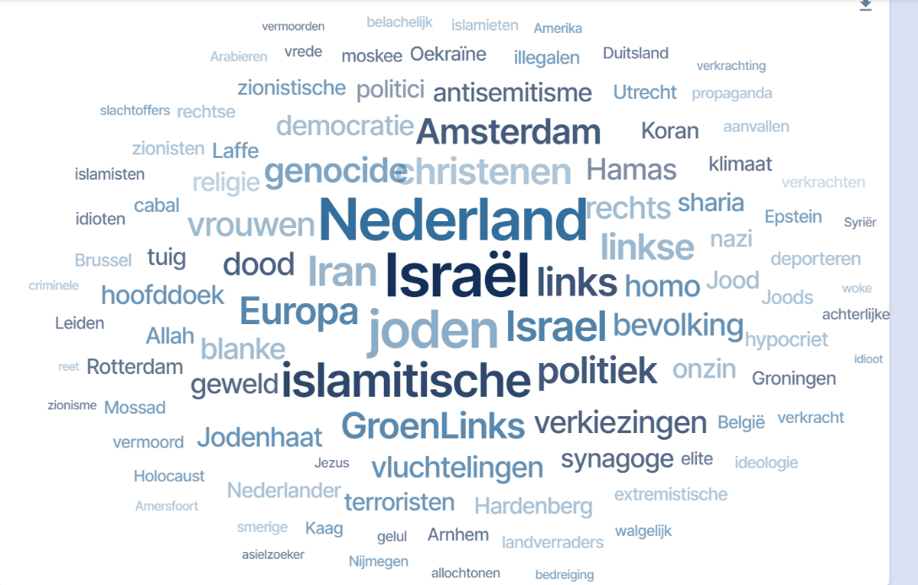

‘Neutral words’ channel

Date | 1 March 2026 - 24 March 2026
Amount | 19,471 posts
% that was toxic of the total dataset | 807 (4.1%)
Average toxicity score | 0.1 %
Platforms where the data was mostly found | Twitter (44%), Instagram (24%) and Youtube (12%)
Often involved | Politics (74%)
% of the posts have a toxicity score of 0.8 or higher (on a scale of 0-1) | 0.2%
% of toxic messages that contained violent language | 18 %

The dataset analyzed covers the period from March 1 to March 24, 2026, and consists of 19,471 posts, all written in Dutch. Of these, 807 posts—representing 4.1% of the dataset—were identified as toxic, with an average toxicity score of 0.10. Only a very small share, 0.2% of posts, reached high toxicity levels with scores of 0.8 or higher. The majority of the data was collected from Twitter (44%), followed by Instagram (24%) and YouTube (12%). In terms of thematic patterns, toxicity was predominantly linked to political discourse, present in 74% of toxic posts, while approximately 18% of these messages contained violent language. Frequently occurring keywords in toxic messages included “boer” (farmer), “rechtse” (right), “Doetinchem,” “Breda,” and “Israël,” indicating a strong connection to political debates, geographic references, and current affairs.

In the word cloud below, one can see the how the elections in this channel are linked to local conversations in different cities around the country. As the table already showed there is little toxic content to be found in this channel.
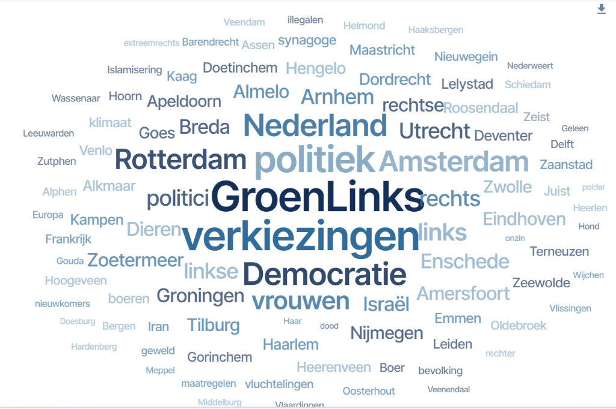

Woke channel

Date | 1 March 2026 - 24 March 2026
Amount | 8,713 posts
% that was toxic of the total dataset | 2,323 (26.7%)
Average toxicity score | 0.34
Platforms where the data was mostly found | Twitter (81%), Facebook (11%) and Youtube (5%)
Messages with high toxicity are more frequent on | Twitter (80.4%)
Often involved | Politics
% of the posts have a toxicity score of 0.8 or higher (on a scale of 0-1) | 1.2 %
% of the toxic messages that contained violent language | 11 %

The dataset analyzed covers the period from March 1 to March 24, 2026, and consists of 8,713 posts, all written in Dutch. Of these, 2,323 posts—representing 26.7% of the dataset—were identified as toxic, with an average toxicity score of 0.34. A small proportion, 1.2% of posts, reached very high toxicity levels with scores of 0.8 or higher. Most of the data was collected from Twitter (81%), followed by Facebook (11%) and YouTube (5%). Highly toxic messages were predominantly concentrated on Twitter, accounting for 80.4% of such content. In terms of thematic patterns, toxicity was overwhelmingly linked to political discourse, present in 94% of toxic posts, while approximately 11% of these messages contained violent language. Frequently occurring keywords in toxic messages included “idioten” (idiots), “islamisering” (Islamisation), “Israël,” “homo” (gay) and “rechts” (right), reflecting a strong overlap between political rhetoric, identity-based language, and polarizing debates. The word ‘islamisering’ (islamisation) representing a conspiracy theory, was used 276 times, even though it was not entered as a key search word in this channel. Words referring to international conflicts also appeared often in this channel; Ukraine, Israel, Iran, Hamas, Russia. The word Amsterdam appeared 248 times. The content containing Amsterdam mostly referred to the city being woke, leftwing and in some cases it referred to Islamisation again.
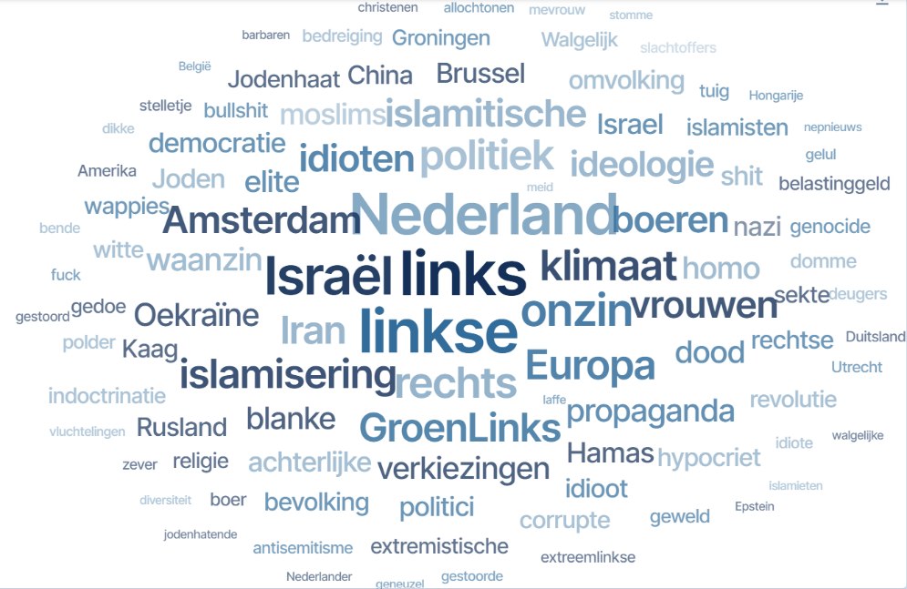

In the graph below one can see the amount of content slightly increasing around 18 March 2026, the date of the elections.
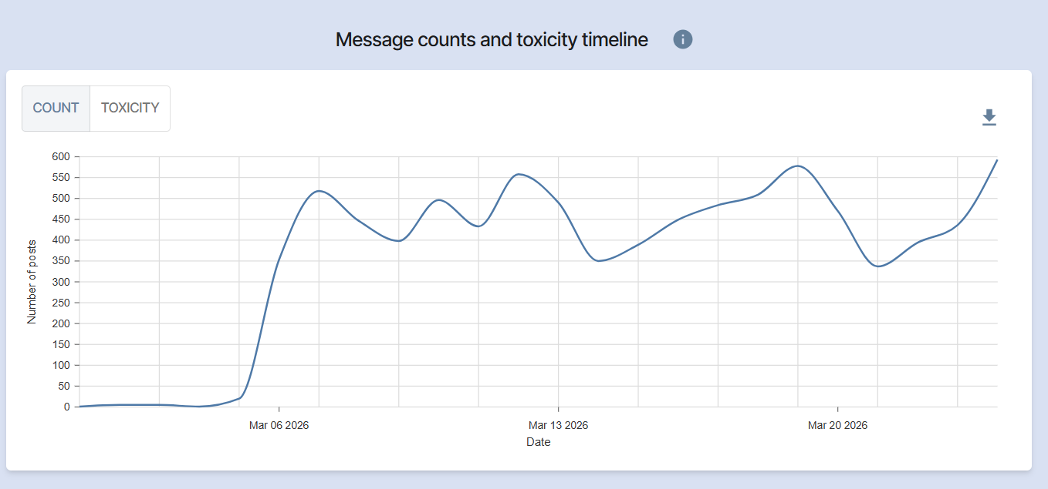

2.2. General patterns and trends

A key overarching trend across all channels is the strong politicization of online hate. Even in channels not explicitly political—such as those focused on anti-LGBT+ or anti-immigration content—hate narratives are consistently framed through political actors, parties, and ideologies. References to left-wing politics, particularly parties such as GroenLinks and D66, appear throughout the datasets. Prominent political figures, including Sigrid Kaag and Rob Jetten, are repeatedly targeted, illustrating how hate speech is not only politicized but also personalized. These individuals are often portrayed as symbols of broader societal changes, which are framed negatively and used to mobilize discontent.
Across multiple channels, there is a strong recurrence of narratives related to migration, “Islamisation,” and the Great Replacement conspiracy theory. These narratives are most explicit in the anti-immigration channel, where racism is highly prevalent and calls for deportation or the closure of asylum seeker centres are common. However, these themes are not confined to a single space. The term “Islamisation,” for example, appears prominently in the “woke” channel despite not being included as a predefined search term, indicating the organic spread and normalization of such narratives across different thematic environments. Similarly, references to Muslims, refugees, and religious identity are present in both anti-immigration and anti-LGBT+ discussions, demonstrating a clear overlap between different forms of exclusionary rhetoric.
This overlap points to a broader pattern: online hate narratives are not siloed but instead form part of an interconnected ecosystem of grievances. The anti-LGBT+ channel, for instance, contains notable references to antisemitism and wider political discourse, while the anti-immigration channel includes discussions about LGBTQ+ identities. The “woke” channel brings these strands together, merging anti-LGBT+, anti-immigration, and anti-left narratives into a single, highly politicized discourse space. These dynamics suggest that different forms of hate reinforce one another, contributing to a cumulative and mutually reinforcing narrative structure.
At the same time, the role of local context within this discourse remains limited. While references to specific municipalities—such as Amsterdam, Hardenberg, Nijmegen, and Amersfoort—do appear, they are rarely discussed in relation to concrete local governance issues. Instead, these locations function as symbolic examples within broader national narratives. Cities like Amsterdam are framed as “left-wing” or “Islamised,” while local debates around asylum seeker centres, such as in Hardenberg or Amersfoort, are used to reinforce national anti-immigration positions. As a result, local issues are instrumentalized rather than genuinely engaged with, confirming that local elections are largely discussed through national and international lenses.
This pattern is further reinforced by the strong presence of international issues across all channels. References to geopolitical conflicts and actors—such as Israel, Ukraine, Russia, Hamas, and Iran—appear frequently, even in contexts where they are not directly relevant. This indicates that global developments are increasingly integrated into domestic political and identity-based narratives, contributing to a discourse that transcends local realities.
Overall, local issues played only a marginal role in the online discourse. When they did emerge, they were almost exclusively framed in relation to opposition to asylum seeker centres. These discussions were rarely confined to local concerns but instead became focal points for broader anxieties around migration, identity, and societal change. More broadly, the conversation was dominated by national, and even more prominently international, issues, reflecting the extent to which online discourse is detached from the immediate realities of municipal politics.
A recurring theme throughout the dataset is the portrayal of the Green Party and left-wing politics more generally as key drivers of the perceived decline of the Netherlands. Progressive policies are frequently framed as undermining national identity, economic stability, and public safety. In parallel, narratives around “Islamisation” reinforce exclusionary and alarmist interpretations of demographic and cultural change. Within anti-LGBTQ+ discussions in particular, this politicization is especially visible, as hostility is directed not only at LGBTQ+ individuals but also at political actors associated with progressive agendas. This illustrates how online hate narratives are deeply intertwined with political discourse, where societal tensions are personalized, amplified, and strategically mobilized.

A key overarching trend is the strong politicization of online hate across all channels. Even in channels not explicitly political, such as the anti-LGBT+ or anti-immigration channels, hate narratives are frequently framed through political actors, parties, and ideologies. References to left-wing politics, particularly parties such as GroenLinks and D66, appear across multiple datasets. Political figures like Sigrid Kaag and Rob Jetten are repeatedly targeted, illustrating how hate speech is personalized and embedded within broader political narratives.

Conclusion

Overall, the findings indicate that local political discourse was strongly overshadowed by national and even international narratives. Rather than focusing on municipal-level issues, online discussions consistently reflected broader debates on migration, identity, and geopolitics. Even when local topics were addressed, they were typically framed through these wider narratives, demonstrating how national and international dynamics shape and dominate local political conversations.
This represents a clear continuation of trends observed in last year’s analysis. At that time, the discourse was similarly dominated by themes related to the conspiracy theory of “Islamisation” and the fear of and hate against asylum seekers, alongside a strong focus on international issues. The current findings suggest that these narratives have not only persisted but remain central in shaping online discussions, further reinforcing the limited visibility of genuinely local concerns within the broader debate.

Recommendations

As highlighted in our previous report on the national elections, these recommendations remain equally relevant following the analysis of the municipal elections. We would like to highlight one in particular:
In line with the Council of Europe Recommendation on Combating Hate Speech, political parties and candidates should publicly commit to a clear code of ethics that rejects hate speech, disinformation, and intimidation. In addition, there is a need to strengthen the capacities of political communicators by providing targeted training on responsible digital campaigning, narrative framing, and the ethical use of social media.

At the same time, effective oversight mechanisms should be established. This includes the development of independent electoral monitoring bodies capable of tracking online campaign behaviour and intervening when certain thresholds are crossed. The examples observed at the level of local branches of the PVV underline the importance of explicitly including local politicians in these efforts, as they may be less aware of the broader impact and amplification of the narratives they deploy for electoral gain.
Finally, platforms should be encouraged to reduce the amplification of harmful—yet not necessarily illegal—content, particularly in the context of political campaigns. This also requires greater awareness among policymakers that harmful content does not need to meet the legal threshold of illegality to have significant societal impact and therefore warrants appropriate attention and response.

Bibliography

- Arnoldy, Charlotte, van der Borst, Bijou, van der Pol, Linda, ‘Hoe Forum voor Democratie de verkiezingen won – en wat dat betekent’, Platform Investico & Groene Amsterdammer, Hoe Forum voor Democratie de verkiezingen won - en wat dat betekent | Investico Onderzoeksjournalisten, 21-03-2026
- BNR, ‘Lokale partijen grote winnaars gemeenteraadsverkiezingen 2026’, Lokale partijen grote winnaars gemeenteraadsverkiezingen 2026 | BNR Nieuwsradio,19-03-2026
- De Teyding, ‘Gemeenteraadsfracties veroordelen bedreiging Schrage: “Van ons collega-raadslid blijf je af!” Gemeenteraadsfracties veroordelen bedreiging Schrage: “Van ons collega-raadslid blijf je af!” – De Teyding, 10-03-2026
- Hart voor Nederland, ‘FVD in meer dan honderd raden na forse winst’, FvD in meer dan honderd gemeenteraden na forse winst | Hart van Nederland, 19-03-2026
- Ibestuur, ’Acht partijen werken samen om online intimidatie richting politici te bestrijden’, Acht partijen werken samen om online intimidatie richting politici te bestrijden, 3-03-2026
- Jonet.nl, ‘FVD zet antisemiet op Haagse lijst gemeenteraad’, FvD zet antisemiet op Haagse lijst gemeenteraad - Jonet.nl, 06-02-2026
- Lubbe, Rozemarijn, ‘1 op 3 FVD-stemmers wil omstreden kandidaten van lokale lijst af, maar de partij zelf nemen ze het niet kwalijk’, EénVandaag, 1 op 3 FVD-stemmers wil omstreden kandidaten van lokale lijst af, maar de partij zelf nemen ze het niet kwalijk | EenVandaag, 11-03-2026
- NOS, ’Verdrievoudiging van bedreigingen en geweld tegen gemeenteraadsleden’, Verdrievoudiging van bedreigingen en geweld tegen gemeenteraadsleden, 16-01-2022
- Van Veluwen, Michiel, ’Gemeenteraadsverkiezingen, haatberichten voor raadsleden: sociale media wel of niet inzetten?’, Sociale Vraagstukken, Haatberichten voor raadsleden: sociale media wel of niet inzetten? – Sociale Vraagstukken, 15-03-2022

